Docker Practice

1. Docker Desktop

* It is a Service Daemon running on an Operating System (Windows, MacOS or Linux)
* In Windows it uses a Hyper-V Virtual Machine as it’s runtime platform (can also use WSL2 for Linux container), the Hyper-V VM is in folder C:\ProgramData\DockerDesktop\vm-data

1. Docker images and Containers

* Docker containers are instances of Docker images, whether running or stopped. In fact, the major difference between Docker containers and images is that containers have a writable layer.
* When you create a Docker container, you’re adding a writable layer on top of the Docker image. You can run many Docker containers from the same Docker image. You can see a Docker container as an instance of a Docker image.

1. Assume we already completed development of a project, and everything is stored in git, the following Windows PowerShell script

|  |
| --- |
| docker run --name repo alpine/git clone https://github.com/docker/getting-started.git |

Will:

* Find and download a docker image (int this case is alpine/git) from Docker Hub
* Download the source code into app/src folder for later docker build

1. Download source file locally



Open C:\Users\john\getting-started

1. Build an Dock Image from a dock file

* Since dockfile is local, we need to run docker build in the local folder
* But the application image was built on the container

1. Show images

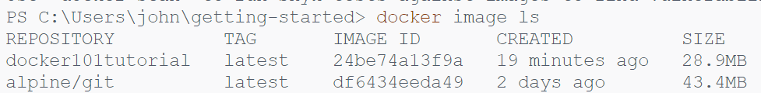

* Alpine/git is the Linux based OS that the container will be run on
* Docker101tutorial is the application image that will be run on the container

1. Run the application on a new container called “docker-tutorial”



* -p 8080:80 means use port 8080 on the host machine to map port 80 on the container
* --name specified the name of the new container
* “docker101tutorial” is the image name that is going to run on the new container

1. Start the container



1. Stop the container



1. Remove the container



1. Docker for .NET Core

* Better to include *.sln and *.csproj into the same folder so that Dockerfile and .dockerignore file will be in the same folder
* In Solution Explorer window, right click Project 🡪 Add 🡪 Docker Support

* Pick OS, either Linux or Windows and this will generate the Dockerfile
* Build

|  |
| --- |
| docker build -t webappdockertest -f Dockerfile . |

* Check Images

* Create container and run the application using docker run:



* Check containers



* Remove an idle container



* Check whether the container has been removed



* And the applications still working

